Equal Weighted Portfolio - Python Solution
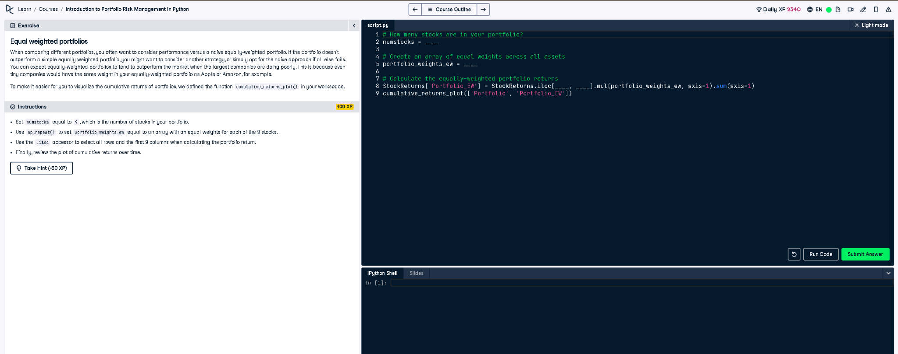
Figure: Screenshot of the exercise on Equal Weighted Portfolios

Full Python Answer
# How many stocks are in your portfolio?
numstocks = 9
# Create an array of equal weights across all assets
portfolio_weights_ew = np.repeat(1/numstocks, numstocks)
# Calculate the equally-weighted portfolio returns
StockReturns['Portfolio_EW'] = StockReturns.iloc[:, 0:9].mul(portfolio_weights_ew, axis=1).sum(axis=1)
# Plot the cumulative returns of both weighted and equal-weighted portfolios
cumulative_returns_plot(['Portfolio', 'Portfolio_EW'])

Simple 50-Word Explanation
This code creates an equally weighted portfolio where each of the 9 stocks has the same weight (1/9). It multiplies each stock's return by its weight, adds them up, and calculates daily returns. Finally, it plots both the weighted and equal-weighted cumulative returns over time for comparison.

